****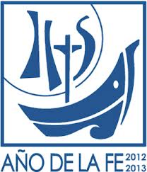****

YEAR 13, N.94

OCtober 2013

## “Mary … I am peace in the storm”

CONTENT:

JUNIO 2013

JUNIO 2013

## **VMY THROUGOUT THE WORLD: EUROPE**

## **Croatia**

## **Spain**

## **France**

## **Italy**

## **Poland**

## **Portugal**

## **PAGE 2**

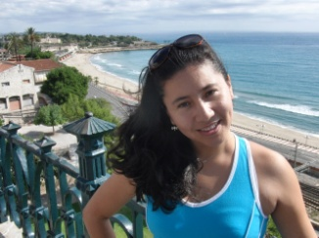

By Karina Mena

International Volunteer

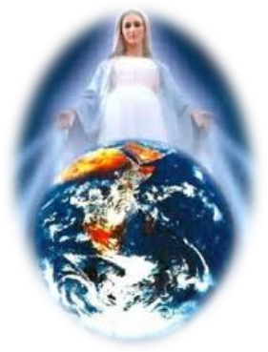

During recent months we have seen and listened to news about many conflicts on our planet, and each party involved has found justification for their attack. I ask myself: Do we not experience internal conflicts which we then externalize? Why do we seek to justify our conflicts by attacking our neighbor?

## **SPIRITUAL LIFE**

## **In the time of Saint Vincent ...**

## **and today**

## **WITNESS**

## **VMY Mexico**

## **PAGE 3**

Pope Francis has stated that true peace originates in the heart of the human person. Where, then, is peace found within us? Each day it is easy to justify our mistakes and yet so difficult to accept them. As a result we live in the midst of an on-going internal war in which we engage in battle with our personal concerns and conflicts at the same time that we have been given a mission to be happy and to communicate that same happiness and joy to our brothers and sisters. How then do we achieve that peace? Throughout history many people have stood before us and shown us how to do this all of them have followed in the footsteps of the Master, Jesus and his mother, Mary, that simple joyful dedicated woman. Mary was filled with faith and one day in Nazareth she stated: I am the handmaid of the Lord. May it be done to me according to your word (Luke 1:38). Mary teaches us to trust in

## **INTERNATIONAL COUNCIL AND SECRETARIAT**

## **PAGE 5**

## **INTERNATIONAL MEETINS**

## **II Africain Encounter**

## **EJV JMJ Brasil 2013**

## **PAGE 4**

God, to believe in her promises and to have faith. She gives us an example of docility to the Word of God and also invites us to act on God’s word: Do whatever he tells you (John 2:5). With those words Mary is asking us to trust her when we are afraid because in Mary we find a courageous woman. Indeed, during our moments of doubt we have only to look into her eyes to discover the truth that she wishes to communicate to us.

To have faith and to believe in a merciful God, to be courageous and to live the truth of Mary’s Son, Jesus Christ, these are the keys to our peace and happiness. Saint John tells us that God and his Son have so loved us that when Jesus saw his mother and the disciple there whom he loved, he said to his mother, “Woman, behold your son.” Then he said to the disciple. “Behold your mother” (John 19:26-27). It was at that moment that the mother of Jesus became the mother of humankind. The sorrowful mother at the foot of the cross speaks to us and tells us that only through faith will we find the strength to confront the various pains and suffering that we will encounter as we walk through life.

Like Mary, let us continue to strengthen our faith so that through the witness of our life we might communicate joy and happiness to those who can find no reason to be happy.

Page

## VMY througout the world: Europe

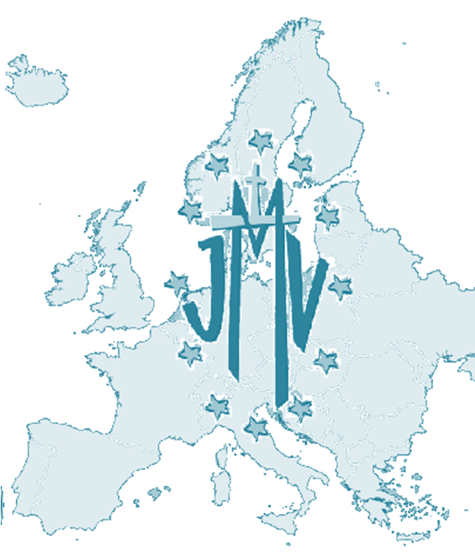**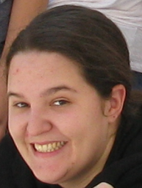Croatia**

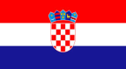This year the VMY in Rijeka has engaged in the process of evangelizing young men and women, the majority of whom are adolescents and live in remote areas where there are no youth groups. They have described their experience as inspiring because they have been able to plant seeds of hope in those areas and this has led to the creation of groups there. The evangelization team has organized new groups whose members regularly participate in visiting the poor in their homes, visiting the sick and organizing activities to raise funds in order to collaborate with the mission of the Daughters of Charity in Bulgaria. VMY in Croatia rejoices is sharing the news that the first religious vocation that was born in the midst of this group has begun her postulancy during the month of October, Her name is Ljubica Brusić (24 years old).

**Spain**

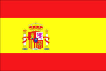During the summer month there were “summer camps” in each Province, thus continuing the Encuentro de Benagalbón, Escuela de Catequistas and La Línea de la Concepción. All of these activities were held under the theme: with a new vision, everything will change. These words are stated in the Pastoral Plan of the VMY and highlight the lay dimension and the service dimension of the Association.

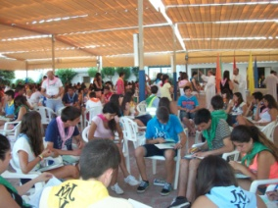In September Provincial Assemblies were held in: Barcelona, San Vicente, Pamplona, San Sebastián, Santa Luisa and in each of these assembles there were formation sessions to deepen our understanding of the theme mentioned above. During these assemblies representatives were elected to participate in the National Assembly. The first phase of the formation of missionaries took place in Las Viñas.

In October Provincial Assemblies were held in: Gijón, Seville, Canarias and Granada. The members of the Association will participate in the beatification of the martyrs of the XX century. There were workshops on idleness and the good use of our free time.

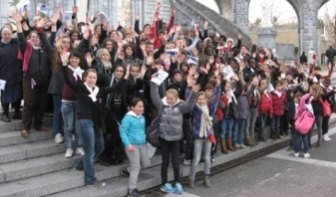**France**

The members began their activities under the theme: We are all one; we are all different; we are all loved by God. The National Assembly will take place on October 5th and will be followed by a meeting of the Advisors. There is now a process of active collaboration with the VMY in Rwanda/Burundi. At various times the members of the group in France have spoken about their work and ministry on the radio.

**Italy**

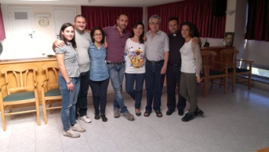 On September 21-22 the National Council met in Rome at the Vincentian Curia. During their meeting they evaluated their experiences during the summer and planed their activities for the coming year. They also presented their own formation document which was based on the international document. On October 12-13 the members will participate in the Marian Encounter of Rome which will be held in the Vatican. The Third National Gathering of the VMY in Italy will take place on November 24 and at that time they will create a website to better their communication.

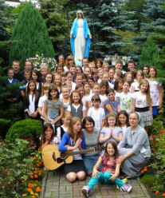

 **Poland** The members have taken as their motto for this year the following words: I long for, I seek and I believe. The VMY in Poland has accomplished various activities that have attempted to bring about a fuller integration of the members into the life of the VMY. During the month of May there was a gathering that dealt with the VMY in the area of study, the objective of this coming together was the integration of adult students into the VMY throughout Poland. This provided an opportunity to dialogue about an up-dated redaction of their magazine Niepokala (The Immaculate One) which will contain interesting themes concerning youth.

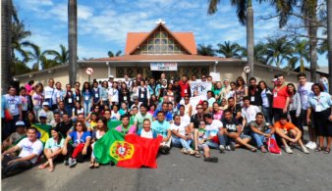**Portugal** The pastoral year (2012-2013) for the VMY in Portugal was developed under the theme: Give witness to the joy of believing! This year the members were called to give witness to their faith and to do this in a joyful manner because faith without works is dead. Here we highlight some of the activities of charity that occurred in Pousal, in the school of Saint Vincent de Paul, in the International Secretariat, in Mozambique and especially in our parishes, because If one does not live in order to serve than it is not worthwhile for one to live.

Page

## In the time of Saint Vincent… and today

## Spiritual Life

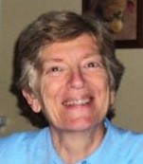By Bernardita García D.C.

Internatinal Delegate

We still hear the echoes of Pope Francis’ words which he spoke in Rio during the celebration of World Youth Day: Go and make disciples of all people! The gospel message is as relevant today as it was during the time of Vincent de Paul. Indeed, there are two urgent needs: the need to proclaim the gospel message to all people and the need for charity, one need cannot be separated from the other.

Vincent de Paul discovered the meaning of the poor when he decided to give his whole life to God. This dedication of his life to God made him clothe himself in the poverty of Jesus Christ. How? He came to an awareness that a person cannot know another person without loving that person. Therefore he spoke to the Daughters of Charity and stated: It is necessary to give oneself to God in order to love Jesus Christ and serve him in the person of those who are poor! Vincent was very aware of the misery of the poor country people, a misery that had been caused by different events which he attempted to resolve. During the seventeenth century Vincent de Paul, as the result of a great conversion, knew how to organize and engage in effective works of charity toward the neighbor. Vincent was shown the way to encounter God as he heard the confession of the dying man in Folleville. Indeed, Vincent was very aware of the suffering of the infirm just as he was aware of the misery of the poor country people. People were touched by the way Vincent acted and many imitated him.

Vincent’s conversion has encouraged many other people to live a life of charity as a response to the call that they have heard from God.

Today we attempt to make real the word of the gospel: Go into the whole world and proclaim the gospel to every creature (Mark 16:15). This proclamation, together with charity, is our positive contribution to building up the Kingdom of God. But what kind of Vincentian service am I involved in? Am I sensitive to the poverty that surrounds me? How do I assist those persons who live so near to me and who are in need? In light of such a situation I can certainly ask the question: what would Jesus do in this situation? This is a key question in order to know how to serve and assist and heal the wounds of so many people who surround us. The solution is found in the love with which we act. To see Jesus Christ in our poor brothers and sisters is not always easy but if we are filled with God and love God then we will find God everywhere, but especially in those brothers and sisters who are most in need. We are God’s instruments and called to communicate the love that God achieved when Jesus laid down his life for us, for all people. We communicate this love not only through our words but also through our witness. Again, the solution is found in the love with which we act, because of your love the poor will forgive you for the bread that you give them.

## VMY in México

## Witness

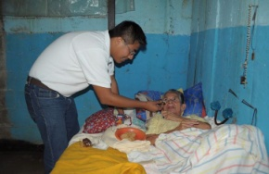

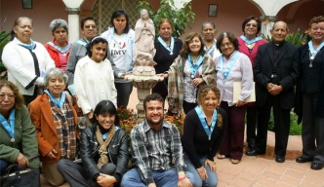Eight years ago I received the grace that enabled me to discover Jesus Christ through the intercession of Mary, his Mother. My name is Miguel Ángel and I am a member of the VMY in Coatepec. It was there that I received my formation and became rooted in Vincentian spirituality. I have been able to engage in team work with other members of the Association and with my own limited experience I began to understand the needs of our brothers and sisters who are poor. This occurred as a result of the experience of other members of the group (persons who are dedicated to the apostolate) and as a result of continual contact with those who are poor. All of this has helped me to relate in a more effective manner with those who are poor. I have been able to put aside my selfish attitude and thus give myself more fully to others. Like Saint Vincent our work is now better organized and more effective. Problems still continue to arise but I attempt to find strength in the Word of God, the Eucharist and prayer. I also attempt, like Mary, to persevere in service to others.

My local group of the VMY is divided into teams and each team visits and cares for some individual or family who is in need. I also offer my services to my parish where I am a catechist and God has gifted me with many wonderful experiences in this ministry of sharing my faith as a catechist and in visiting the homes of those who are poor and infirm and in need. In my work with children I have also become aware of the reality of poverty and together with the other members of the VMY we continue to look for effective solutions to this problem. As a member of the VMY I am responsible for the area of formation which is a difficult task because formation depends on the value that we, as young men and women, place on ourselves as persons and also involves our relationship with Jesus and with his Mother, Mary, as well as our commitment to the church, and especially our commitment to those who are poor. Even though this work is difficult it is also very satisfying because it enables me to plant seeds of love, love of God and the Virgin and the poor.

 I could say many more things but I simply want to express my gratitude to God for having allowed me to serve him in those persons who are poor. Even though I am aware of my limitations God has called me and has allowed me to be a member of the VMY which, for me, is like being enrolled in the school of Mary where I have learned to relate to the person of Jesus Christ as he is present in my own life and in the life of those who are poor.

Page



## International Meetings

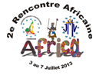

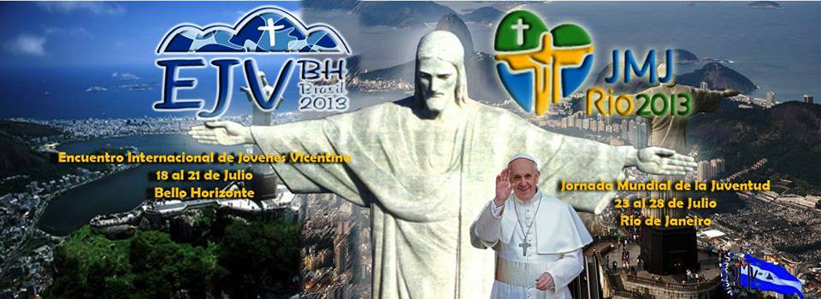

**Second African Encounter of VMY National Councils**

**Cameroon 2013**

“VMY, disciples and witnesses to Christ who are strengthened by hope”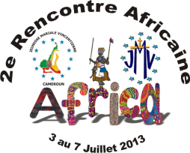

From July 3-7, 2013 the Second African Encounter of the Vincentian Marian Youth Association was held at the Salesian House “Don Bosco” in Yanudé. There were twenty-three delegates/participants from six countries: the Democratic Republic of the Congo, Burundi-Rwanda, Kenya, Ivory Coast, Nigeria, and Cameroon. This gathering included the support and the participation of the Daughters of Charity and the Missionaries of the Congregation of the Mission Father Thomas Lunot, CM (representative of the Superior General) accompanied us during the meeting.

Three attitudes prevailed during our gathering: listening to the Lord, to one another and to the Holy Spirit; active participation and commitment, that is, to share with our groups that which we learn here during this encounter.

Our work was focused on the situation of the VMY in Africa and we utilized a method of analysis that allowed us to enter into a discussion of strengths, opportunities, weaknesses, and threats. This work was directed by Ghislain. The global vision of the VMY was presented by Bienvenu Fouda and Yasmine directed a workshop on systemic change and spoke about the Marian characteristic of our Association.

We then dedicated time to the primary theme of the encounter: the symbols of the Miraculous Medal as reflections of the symbols of our faith. This presentation was given by Father Thomas Lunot, CM and was based on the papal encyclical, Porta Fidei. Father Thomas explained the significance of biblical symbols and the symbols in the rite of Baptism. He then presented the Creed (twelve articles of faith) and related each statement of faith with a symbol of the miraculous medal. This was followed by a presentation by Yasmine and Ghislain in which ways were explored to improve the quality of life of the members in the Association. Here there was an emphasis on the spiritual accompaniment of the members.

During a cultural presentation we celebrated the rich cultural heritage of Africa which was expressed in song and dance and typical clothing.

During the afternoon of July 6th we visited some of the sights in Yanudé (despite the rain).

On Sunday, July 7th, the final document of the Encounter was approved. Announcements were made concerning up-coming events and the annual letter of the President was distributed. The closing Eucharist was a festive celebration and each participant was given a cross (made by a prisoner) and the miraculous medal. The international team thanked all those who made the encounter possible, especially the volunteers, the National Council and the Vincentian Family in Cameroon.

All the participants were sent forth as disciples and witnesses of Christ. They were strengthened in hope and dedicated to live the commitment that they had assumed. Even though many groups and other members of the Vincentian Family were unable to participate, nevertheless, their prayers were felt. We are convinced that the Lord will bless these efforts to build up the kingdom of God.

INTERNATIONAL TEAM

**Vincentian Youth Gathering and World Youth Day**

**Brazil 2013**

For the second time I had the opportunity to experience one of the greatest gatherings of Catholic, Vincentian young men and women from throughout the world a truly incredible event that demands much preparation. The Vincentian Youth Gathering took place in Brazil since the World Youth Day celebration was scheduled for Rio. In both of these gathering one was able to feel the joy that results from being related to one another in such a profound manner.

The Vincentian Youth Gathering took place in Cidade dos Meninos, part of the metropolitan area of Belo Horizonte. As a member of the Vincentian Family I was profoundly impressed by the group experiences in the theatre (the primary meeting place). The activities there took place before we left for the workshops and the other activities. These were always very animated and very moving. During one of those days, after reflecting on the life and work of the founder of the Saint Vincent de Paul Society, Frederic Ozanam, a net was extended from the front to the back of the theatre this represented the net of charity, Frederic’s dream and challenge which today we share. It was very impressive to watch the net become entangled in our arms as we sang the hymn Viva la juventud Vicenciana (Long live the Vincentian Youth!). Equally impressive was the vigil dedicated to the Blessed Mother and celebrated on such a significant day, July 18th, the day of the first appearance of the Blessed Mother to Catherine Laboure. All of the young men and women from the five different continents meditated on the rosary during a procession with more than a thousand lighted candles. At the end of the procession different images of Mary were presented images that represented people from various nations, the last image to be unveiled was that of Our Lady of Aparecida, the patroness of Brazil, and we all sang the hymn Peregrinación, a hymn of the Brazilian people.

During the celebration of World Youth Day I was proud to be able to say that I was among the 3,700,000 young people who participated in some of the most incredible events that Brazil had ever seen. Incredible as it might sound, even though there were so many people gathered together in one place there was never any serious problem. Truly, God was with us. To experience the profound silence during the exposition of the Blessed Sacrament and to listen to the movement of the waters of the Copacabana in the background moved me to tears of joy. Because I was able to use the credentials of Yasmine Cajuste, the International President who was unable to attend, I was able to move closer to the place where Pope Francis presided and witnessed the joy of the young men and women from Poland at the time that the Pope announced the place of the next World Youth Day.

During this time there was much rain and many cold days and nights, there were long lines and some problems with transportation but they were days that changed our lives! The group of 18 people who left Rio with me after the celebration of the Vincentian Youth Gathering and World Youth Day were more united and for this we give thanks to God.

For me the celebration of the Vincentian Youth Gathering is like life itself full of surprises and challenges that can only be confronted by people of faith. I am very grateful for the formation in the faith that was imparted to me by the Saint Vincent de Paul Society and by the Vincentian Marian Youth Association, I am also most joyful for having received this formation. Long live the young men and women, the youth, throughout the world!

Clarissa Paiva

Lay Advisor of the VMY and

Member of the Vincent de Paul Society

Page

## International Council and Secretariat

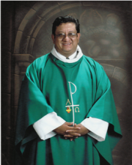 On September 1st, Father Irving Amaro Ramayo became the International Sub-director of the VMY and the Director of the International Secreatariat.

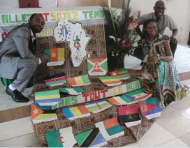 Yasmine Cajuste (Internacional President), Ghislain Atemezing (Councilor for Africa), Bienvenu Fouda (Frech Speaking Volunteer) and Father Thomas Lunot (Representative of the Superior General), participated in the II African Encounter of the National Councils of the VMY which was held in Yaundé, Cameroon from July 3-7, 2013. We thank the National Council and the Vincentian Family in Cameroon for their hospitality and the time that they spent in preparing for this meeting.

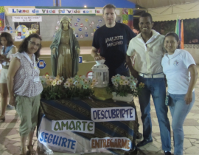 From July 16-28 the team at the Secretariat participated in the National Meeting and Catechetical School “Benagalbon – 2013”. During those days there was time for sharing experiences and sharing life in community and there were sessions of on-going formation. We thank the VMY in Spain for the opportunity to participate in this experience.

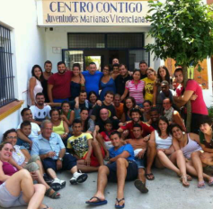

 During the summer (from August 4-20) the members of the Secretariat participated in Centro Contigo de la Linea de la Concepción which providied us with an opportunity to discover and share some new ways of identifying and living in solidarity with the children and young men and women who are part of this project.

 Bienvenu Fouda represented the International Secretariat at the XXXVIII Vincentian Studies Week that took place from August 19-23 in the city of Salamanca, Spain. The theme of the week was “In the service of faith and charity”.

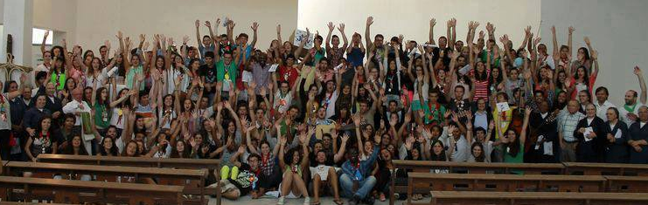  From August 21-25 Rita Bemposta and Bienvenu Fouda participated in the XXIX National Encounter of the VMY in Felgueiras (Portugal).  We express our gratitude to the young men and women who welcomed us and provided us with this opportunity to share the importance of our faith as we dialogued about the theme “The joyful witness of belief”.

## @sijmv

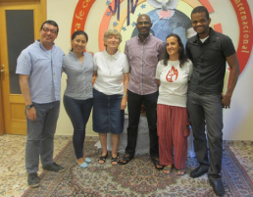 During the month of September Father Castillero provided the team at the Secretariat a workshop entitled “Personal Growth”.  During three weeks we lived a time of intense spiritual and personal enrichment.

**VMY INTERNATIONAL SECRETARIAT**

C/José Abascal, 30. 28003 Madrid. España Tel. 34 91 591 2164 Fax. 34 91 119 1306

*E-mail:* **secinterjmv@gmail.com / delinterjmv@gmail.com**



Page

C/José Abascal, 30. 28003 Madrid. España Tel. 34 91 591 2164 Fax. 34 91 119 1306

*Correos:* secinterjmv@gmail.com **/ delinterjmv@gmail.com**

**www.secretariadojmv.org**

Page